Welcome to BSNL Thanjavur Marketing cell

BSNL Mobile National Roaming Free STVs are going to be Flagship Plans

Subscribe with BSNL Mobile Roam Free Ratecutters & Enjoy Free Incoming Calls for 1 day to 90days

BSNL Mobile Plans whatever it may be.. It will have good response. Its like a Maruthi Car line-up..Whether it can be 800/Alto/Wagon-R or even Swift/Ertiga…Limited models but have the majority share. In the same line BSNL Mobile Plans appears to be limited, but they are people’s plans which are widely accepted.

BSNL Mobile National Roaming Free STVs

BSNL introduced National Free Roaming Plans which appears like tailored for your requirements, and being a state owned company, may not have that much flexible to introduce new plans at any point of time. Still BSNL's National Free Roaming Plans are the Flagship plans, which are a big hit in the mobile market starting from Rs.5 a day to Rs.90 for 3 Months.

For every BSNL Mobile customer, who travels in National Roaming areas, the amount for a day or for three months will not be a big deal and being BSNL which is having PAN India service access really makes sense to go for these Flagship plans. So Be a BSNL Customer & Be Happy to avail the best BSNL National Free Roaming STV's which are a bit hit in the market.

@@@

BSNL introduces new postpaid add-on packs for its customers
BSNL has been dealing with losses off late but is trying to make a comeback by introducing new offers across its services. It has just introduced new postpaid add on packs to add value to the usage of the postpaid customers. These are:
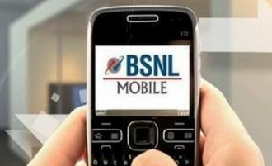
- Single bill for up to 5 customers: Up to 5 users can opt for a single bill by paying a monthly charge of Rs 25/month and providing their consent in writing before availing the service. However, if the monthly charge for the individual plans cost more than Rs 525, the service can be availed for free.
- Free Calling: Free calling between up to 5 numbers on BSNL network (local) will be provided under this alongside the facility of free calling by all the numbers to a local BSNL landline number. This will charged at Rs 25 individually. So for instance, if “A” wants to add “B”, both will have to pay Rs 25/month and can enjoy unlimited calling among themselves.
- Free Calling to landline: If you’ve opted for the above Closed User Group service, you can opt for free calls to a landline number outside your circle as well. This will be available at Rs 50/month.
- Pool and Share Facility: Under this up to 5 numbers can share the benefits of their plans among them @Rs 25/month/subscriber. However, it will be free if the FMC for these numbers is more than Rs 525/month.
- Combo Add On: There’s a comboadd on as well which gives you access to all the above services in one go.
  - Single bill for maximum five numbers (on-net numbers).
  - Free calls within above specified maximum 5 numbers.
  - Free calls to any one specified on-net landline number (within Local Service Area). Single/same number shall be specified by all the CUG (Closed User Group) members.
  - Free call facility to any one specified on-net mobile/landline number (outside LSA). Single/same number shall be specified by all the CUG members.
  - Pool and share facility of freebies among above 5 on-net numbers whereby, members would be able to share their freebies.
  - Free National calling (on-net/off-net which is basically within BSNL’s network and outside its network) for one hour on 1st of every month, or free National on-net calling for full day on 1st of every month. Any one option may be chosen by the subscriber.
  - For availing this, you need to pay Rs 25/month and it will be free if your plan is above Rs 525/month. For getting all the above services in the combo plan, you need to pay Rs 100/user.

@@@@

NTP 2012: Will broadband speed be upgraded to 2 Mbps in 2015?
Two years back the groundbreaking National Telecom Policy 2012 was made which was set to transform telecommunications in India for new digital era. While the government managed to implement some of the recommendations, most of them are still just on paper. One of the key recommendations of the policy was to increase minimum broadband speed to 512kbps and subsequently to 2 Mbps by January 1st 2015.

National Telecom Policy 2012
The National Telecom Policy 2012 was set to replace more than 12 years old telecom regulations and was approved by the Union Cabinet on May 31, 2012. Its vision was, “to provide secure, reliable, affordable and high quality converged telecommunication services anytime, anywhere for an accelerated inclusive socio-economic development”.
Lets take a look into key recommendations and its current status of implementation.
• “’Broadband For All” at a minimum download speed of 2 Mbps – Broadband speed increased to 512kbps
• Domestic Manufacturing- Making India a global hub – Now part of Make in India Campaign.
• Liberalisation of Spectrum- any Service in any Technology – Implemented
• Unified Licensing, delinking of Spectrum from License, – Implemented
• One Nation – Full Mobile Number Portability and work towards One Nation – Free Roaming – Pending
• Voice over Internet Protocol, Cloud Computing, Next Generation Network including IPV6 – Pending
• 175 million broadband connections by 2017 and 600 million 2020 – 79.21 million as of October 2014
• Allow trading, sharing, pooling of spectrum – Pending
Minimum broadband Speed
The policy pointed out broadband speed in India was very low at 256kbps and recommended to revise it to 512 Kbps by the end of 2012 and subsequently to 2 Mbps by 2015, with higher speeds of at least 100 Mbps on demand. After long delays TRAI redefined broadband as data connection providing minimum 512 kbps speed. This resulted in revision of existing unlimited broadband plans by ISP to minimum 512Kbps even for post FUP usage.
Now coming to 2 Mbps download speed which should be implemented by 1st January 2015. As of now there is no word on the progress or any plans to implement it any time soon. ISPs will oppose this move as they just moved to 512 kbps and moving towards 2 Mbps will cost huge overhead. In short 2Mbps minimum broadband speed will get further delayed, like other NTP 2012 recommendations.
Consumer point of view
Average broadband speed in India is at 1.7 Mbps which ranks India 114th globally. Unlimited broadband plans are still expensive and throttled by FUP. Recently many cable broadband service providers across the country upgraded their network to up to 50 to 100 Mbps speed, but with FUP on most plans. Reliance Jio preview website showed a glimpse of its plans to provide 100Mbps through fiber to home which was also promising.
In this digital age we require at least 10Mbps connection to stream HD videos from Youtube/Facebook. 2Mbps minimum broadband speed will give an interim relief for consumers frustrated with FUP on unlimited plans. But may also cause a tariff hike or complete withdrawal of lower speed plans by ISP.
Conclusion
Government is pushing hard towards digital India with National Optical Fibre Network (NOFN) across all 2.5 lakh village panchayats set to be completed by December 2016. This is expected to provide up to 100Mbps speed to gram panchayat. This would eventually increase broadband speed in the country. But in order to fully achieve digital India goals, government would eventually has to implement minimum 2 Mbps or more broadband speed.
Do you think government will fulfill the promise of 2mbps minimum broadband speed by 1st January 2015? Do let us know via comments.

@@@

TRAI report card: BSNL tops in wired broadband as of october 2014
The number of broadband subscribers between September and October has increased from 75.73 million to 79.21 million in India, according to Telecom Regulatory Authority of India (TRAI).
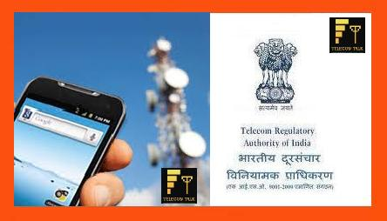
The largest growth in broadband during October this year was among mobile devices users (phones and dongles), registering a growth of 5.75 per cent growth. On the other hand, there was no change between September and October in fixed wireless subscribers (Wi-Fi, Wi-Max, Point-to-point radio and VSAT) with the figures remaining at 4,20,000.
But wired subscriptions showed a minimal growth going up from 15.13 million to 15.15 million, registering a monthly growth rate of 0.16 per cent. The regulator said Wireless subscribers with less than 1MB data usage in a month have not been considered as internet/broadband subscribers by Reliance Communication Group and Idea Cellular.
The top five Wired Broadband Service providers as on 31 October.
BSNL (9.97 million), Bharti Airtel (1.40 million), MTNL (1.13 million), Beam Telecom (0.43 million) and YOU Broadband (0.41 million).
The top five Wireless Broadband Service providers
The top five Wireless Broadband Service providers were Bharti Airtel (15.91 million), Vodafone (14.15 million), Idea Cellular (11.47 million), BSNL (9.16 million) and Reliance Communications Group (6.48 million).

@@@@

BSNL subscriber base shrinks to 8.94 cr in June

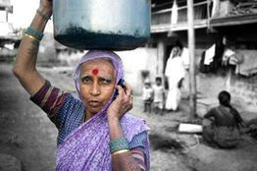
State-run telco BSNL has reduced its subscriber base by over 21 lakh wireless subscribers to 8.94 crore in June as it did away with non-active users.
"The reason for the decline is that we are removing non-active customers as part of the clean-up. The non-active users have been accumulating in the user base for the last 10 years and now we are removing them," media reports said quoting BSNL director (consumer mobility) Anupam Shrivastava.
Other state-run operator MTNL too lost 30,304 users during the month and its base got reduced to 33.66 lakh, according to Telecom Regulatory Authority of India.
The government is likely to merge PSU telcos BSNL and MTNL with organizational restructuring as it plans to revive the two firms.
Just recently, telecom minister Ravi Shankar Prasad had said that the government is committed to the revival of BSNL. He cited inadequate investment in infrastructure expansion leading to delay in expansion of mobile network and paying market rate (of Rs 18,500.38 crore) for both 3G and broadband wireless access (BWA) spectrum as the reasons for the downfall of the company.
Earlier, the minister had said that the government will invest Rs 39,458 crore in loss-making PSU telcos BSNL and MTNL.
"The financially-stressed public sector telecom companies that together have a debt of Rs 21,208 crore as of June-end, face declining revenue due to loss of market share, increasing expenditure and inability to invest in network expansion," the telecom minister had said.
BSNL has debts to the tune of Rs 3,335 crore in March 2012, which rose to Rs 6,448 crore in June 2014, while MTNL's debt has gone up to Rs 14,760 crore end of last month from Rs 9,648 crore in March 2012.
The market share of BSNL has got reduced to 12.3 per cent at the end of May 2014 from 13.27 per cent at end of March 2012, while MTNL stood at 4.83 per cent at May-end, 2014.
@@@@

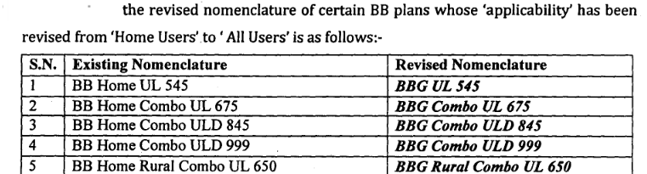

Only three BSNL territorial circles made profit in 2013-14
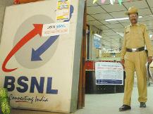
BSNL had reported a loss of Rs 7,772.54 crore in 2012-13 and Rs 8,652.61 crore in 2011-12, the minister added.
NEW DELHI: State-run BSNL made profit in only three territorial circles of Kerala, J&K and Odisha and overall, it reported a loss of Rs 6,933.25 crore in 2013-14.
Sharing the profit/loss details of BSNL, Communications and IT Minister Ravi Shankar Prasad said in a written reply to the Rajya Sabha the company reported a loss of Rs 6,933.25 crore in 2013-14, while recorded profits of Rs 396.80 crore in Kerala, Rs 9.37 crore in J&K and Rs 5.16 crore in Odisha.
The state-run telecom firm also reported profit for various non territorial circles like its corporate office, Northern telecom project and maintenance New Delhi, among others but on overall net basis, the firm suffered a loss.
BSNL had reported a loss of Rs 7,772.54 crore in 2012-13 and Rs 8,652.61 crore in 2011-12, the minister added.
"Government is conscious that the performance of BSNL needs substantial improvement and has been taking measures to address the present problems," Prasad said.
The minister said financial support of Rs 6,724.51 crore has been provided to BSNL on surrender of broadband wireless spectrum and Rs 1,411 crore waiver on government loan granted to the company.
"BSNL reported total revenue of Rs 27,996.35 crore in 2013-14 whereas total expenditure stood at Rs 34,929.60 crore. In 2012-13, total revenue was Rs 27,127.89 crore against a total expenditure of Rs 34,900.43 and for 2011-12, the total revenue was Rs 27,933.50 crore and total expenditure was Rs 36,586.11 crore," he added.
BSNL is also taking steps to increase its revenue through investments by strengthening network and focusing on customer care and service delivery.
The company is undertaking augmentation of its mobile network as part of its phase-VII project to create additional capacity of 15 million lines at an estimated cost of Rs 4,804.77 crore which will result in addition of 14,421 2G sites and 10,605 3G sites across the country.
BSNL is replacing its entire network of wireline local exchanges by internet protocol enabled exchanges and deployment of next generation network equipment at an estimated cost of Rs 600 crore.
Apart from that the government has assigned work of providing mobile connectivity to left wing extremism areas to BSNL at an estimated cost of Rs 3,567.58 crore and providing mobile connectivity to uncovered villages in Arunachal Pradesh and two districts of Assam for Rs 1,975.38 crore.

@@@@@

Bringing down the Retirement Age to 58 years will not solve the unemployment problem
“The Financial Express”, one of the leading newspapers recently published a news article on the Central Government’s plan to reduce the retirement age of employees from 60 to 58. This news shocked the central government employees.
“Reducing the retirement age of central government employees from 60 to 58 will help to solve the unemployment problem in India?”
Reasons cited for decreasing the retirement age from 60 to 58:
The following reasons are attributed for decreasing the present age of retirement:

1) To create more employment opportunities for the youth
2) To increase the contribution of younger employees in the government sectors and
3) To compensate the loss accrued due to payment of allowances
Unemployment issue:
None can have any disagreement about the fact that employment opportunities should be provided for the unemployed. There are so many ways for solving the unemployment problem. They are:
1) Introducing new employment policies
2) Filling all the positions lying vacant and
3) Promoting self-employment by introducing new schemes and providing suitable facilities and many more ways can help to solve the problem of unemployment.
Increasing the retirement age from 60 to 62 for scientists:
In the Rajya Sabha,in a written reply to a question raised on increasing the retirement age for scientists from 60 to 62 , the Government said, “it is under consideration”.
The important reasons for increasing the retirement age for scientists are:
1) Their experience and expertise should benefit the younger generation and
2) The average life span has increased.
Allowance issue:
Extra allowance that has to be paid is cited as a reason for bringing down the retirement age of employees from 60 to 58. However, in reality, the pay commission is set up only once in 10 years and benefits the central government employees.
“In the long interval of 10 years, only these allowances help the employees to cope with inflation”.
In the past, the average service period of a central government employee was 30 to 40 years. Presently, as the age limit for appointment has been relaxed, the average service period has come down to 20 to 30 years. Due to this, an employee can only have 2 or 3 pay commissions in his service period.
In this situation, citing allowance as a reason for decreasing retirement age and altering the present allowance rates will adversely affect the economic condition of central government employees.
Average retirement age in the world:
The average retirement age of government servants in many country is between 63 and 65. Comparatively speaking, even the age of 60 is obviously a very early age for retirement. In this context, we do not know whether the central government employees will accept 58 as the age of retirement.
Will early retirement solve the unemployment problem?
Employment for unemployed is a very important issue. It is the duty of the Government to provide employment opportunity to all the Gen Y and lead them in a better way. The hope and aspiration of every youth in this country is to get a good job. They do not expect the retirement age of central government employees to be brought down from 60 to 58.

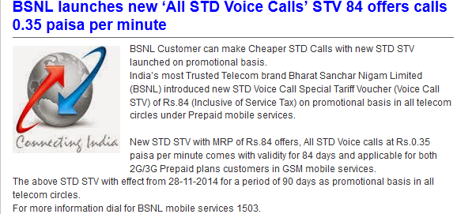

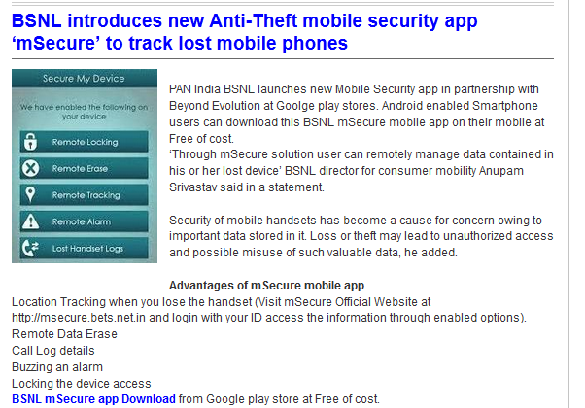

https://play.google.com/store/apps/details?id=in.bets.msecure&hl=en

@@@@

750,000 km of cable to connect all villages with broadband: Prasad
Minister for Communications and Information Technology Ravi Shankar Prasad has said that 750,000 km of cable is proposed to be laid over next three and a half years to provide broadband in every village of the country, the ministry said in a statement Sunday.
"This project aims at digital empowerment of people and will be a game changer," Prasad, said at the first MyGov Samvaad programme here Saturday evening, interacting with contributors of ideas for the Digital India project.
MyGov is an internet-based platform for citizen engagement launched by Prime Minister Narendra Modi on July 26.
The minister also felicitated 20 of the best contributors for their ideas and responses from out of over 40,000 responses, the statement added.
Prasad told the contributors that there is a need to sensitise people about the power of technology.
India now has about 300 million internet users, which figure is crossing the number of internet users in the US, that is second on this count after China, the minister added.
He pointed out that while in urban India mobile connectivity is 146 percent, it is only about 46 percent in rural areas.
Prasad said electronic manufacturing is also being promoted in the country in a big way.

@@@@

BSNL, MTNL call drops echo in Lok Sabha
NEW DELHI: Members in the LokSabha on Monday expressed concern over the sorry state of affairs in state-owned BSNL and MTNL which is causing problems for millions of mobile users all over the country daily due to poor connectivity.
Raising the issue during Zero Hour, K Geetha (YSR Cong) said MPs who have got BSNL mobile connections face the problem of call dropping in spite of being connected through MTNL.
Geetha got instant support from all sides. She wondered whether the problem in BSNL's mobile services were due to private players playing dirty or inefficiency of the telecom operator. She claimed poor connectivity was due to several telecom towers of BSNL either not in operation or operating erratically.
Supporting her, Arvind Sawant (Shiv Sena) alleged connectivity issues were deliberate in nature and meant to suit private players.
Balabhadra Majhi (BJD) complained that only last month he had to force authorities to postpone the examinations for recruitment of postmen as several of the aspirants from his constituency comprising Malkangiri and Navrangpur district could not download the admission cards due to poor connectivity.
BJP member Narayanbhai Kachhadiya also said 15 BSNL towers were installed several years ago to serve 800 villages in western Gujarat but have not been activated yet and there was no connectivity in most of the region.
Parliamentary affairs minister M Venkaiah Naidu conceded that this was indeed a problem and he had seen the poor connectivity at Vishakhapatnam where students or job aspirants were not able to apply online.
He said he would convey the members' concern to the communications minister so that steps to rectify the problems are taken soon.

@@@@@

***ENJOY BSNL 50MB FREE DATA OFFER
For TOPUP Rs.100 & Rs.200

@@@@@

Rs 2179.41cr penalty imposed on telecom companies for violating CAF rules
PTI Dec 10, 2014, 04.30PM IST
- 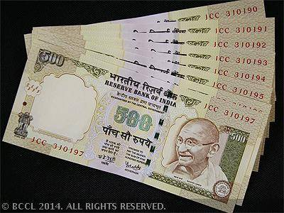
(The minister said the Department…)
NEW DELHI: A total penalty of Rs 2,179.41 crore was imposed on telecom operators till September 30, 2014, for violation of customer verification guidelines, the government said today.
In a written reply to the Lok Sabha, Communications and IT Minister Ravi Shankar Prasad said, "A total penalty of about Rs 2,179.41 crore has been imposed since the inception till September 30, 2014 on telecom operators for violations of verification guidelines."
The minister said the Department of Telecommunications (DoT) issued latest instructions on August 9, 2012, on subscriber verification.
The maximum penalty has been imposed on Aircel at Rs 486.48 crore followed by Reliance Communications at Rs 454.62 crore. State-run BSNL was imposed a fine of Rs 329.14 crore, Bharti Airtel at Rs 309.87 crore, Vodafone at Rs 211.85 crore and Idea Cellular at Rs 123.44 crore for violation of norms, according to the reply.
A penalty of Rs 172.80 crore was imposed on Tata Teleservices, Rs 52.31 crore on Sistema Shyam Teleservices, Rs 11.65 crore on Uninor, Rs 11.17 crore on MTNL and Rs 10.92 crore on STel.
Prasad said the verification of identity of mobile phone users is mandatory and the DoT has been issuing instructions from time to time for the same.
"These instructions contain procedures for verification of identity of mobile subscribers which stipulate that mobile connection should be issued on the basis of documents as proof of identity and proof of address," he said.
The list of documents include passport, driving licence, election commission ID card, arms licence, PAN card and Aadhaar card among others.
Prasad said the Department has found from the audit of customer application forms (CAF) that only about 4 per cent of CAF were non-compliant to the subscriber verification guidelines during 2013-14.
The reasons for non-compliance include missing CAFs, missing photo/proof of identity/proof of address on CAF, subscriber's acquisition based on apparently forged documents, pre-activated mobile connections and bulk connections issued to an individual or a company or an organisation.
"By invoking licence conditions, the government has prescribed penalties to be imposed on telecom service providers who, during audit, are found non-compliant to the licence conditions and instructions issued by the government on the subject of CAF verification," the Minister said.
The amount of financial penalty is calculated on the principles as followed in the income tax system i.e calculating the financial penalty separately by applying the corresponding slab rate and then arriving at total amount of penalty.

@@@@@@@

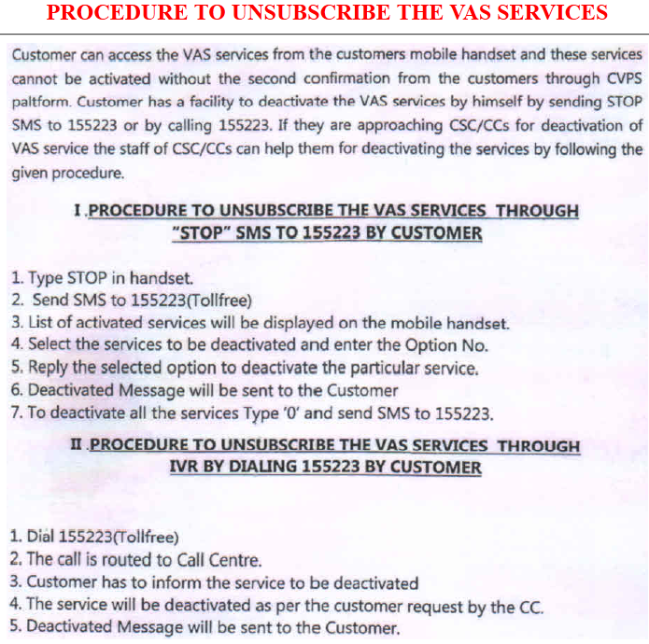@@@@@@

Telecom Commission asks DoT to review its stance on BSNL’s 900 MHz spectrum issue
Thursday, 11 December 2014
The Telecom Commission has directed the Department of Telecommunications (DoT) to review its stance on taking back spectrum in the 900 MHz band from Bharat Sanchar Nigam Limited (BSNL). The commission has also asked the telecom department to give its recommendations on the matter.
The Commission has however clarified that any decision concerning BSNL’s 900 MHz spectrum will have no effect on the forthcoming February 2015 auction. The government is likely to put at least 184 MHz of spectrum in the 900 MHz band for the February 2015 auctions.
Meanwhile, BSNL is considering seeking government grant in exchange for returning spectrum in the 900 MHz band. The company is willing to return 1.2 MHz of spectrum in 900 MHz in 18 circles (barring Punjab) where its licences expire in 2015-16, which is in line with the recommendation of the Telecom regulatory Authority of India, in exchange for compensation of nearly Rs 20 billion. BSNL requires these funds to meet its additional capex and network re-engineering costs.

@@@@@@

BSNL, MTNL Losses at Rs. 3,785 Crores and Rs. 1,567 Crores: Prasad

State-owned telecom firms BSNL and MTNL have incurred losses of Rs. 3,785 crores and Rs. 1,567 crores till September 30 in the current financial year and steps are being taken to revive them, government said Tuesday.
The losses are on account of decline in revenue and increase in expenditure, Minister of Communications and IT Ravi Shankar Prasad said in a written reply to the Lok Sabha.
At present, there is no proposal for disinvestment in MTNL and BSNL though the government is in the process of revival of the two firms through various short term, medium term and long term measures, he added.
"The long term measures, including merger of BSNL and MTNL, would attempt to position these PSUs to emerge as market leaders in the converged telecommunication market," he said.
BSNL's provisional and unaudited loss up to September 30 for 2014-15 fiscal stood at Rs. 3,785 crores, whereas that of MTNL was Rs. 1,567 crores, he said.
BSNL had incurred Rs. 7,019 crores loss in 2013-14, Rs. 7,884 crores in 2012-13 and Rs. 8,850 crores in 2011-12, whereas MTNL had reported a loss of Rs. 4,109 crores in 2011-12 and Rs. 5,322 crores in 2012-13.
The revenue has declined for reasons including fixed to mobile substitution leading to surrender of wireline connections, delay in expansion of GSM capacity, perceived poor quality of customer services and high reduction in income from sources other than services, the minister said.
The expenditure of these firms has increased because of legacy workforce whose salary and wages are more than 50 percent of revenue, increasing repair and maintenance costs and high interest burden in case of MTNL.
Prasad said: "MTNL has shown a profit of Rs. 7,825 crores in 2013-14 mainly due to write back of provisions on account of pensionary liabilities and spectrum amortisation costs after decisions of government taken for revival of MTNL."
The government has taken several measures in an attempt to bring the two state-run companies out of financial distress.
The measures include treatment of pensionary liabilities of government employees absorbed in MTNL who opted for combined service pension on parity with similar employees in BSNL, waiver of government loan to BSNL involving an amount of Rs. 1,411 crores and financial support of Rs. 492 crores to MTNL towards payment of minimum alternate tax.
"The government has given financial support of Rs. 6,724.51 crores to BSNL and Rs. 4,533.97 crores to MTNL on surrender of broadband wireless access spectrum," Prasad said.
He added that the two firms are separately preparing a revival plan for increasing revenue potential, identifying business opportunities, organisational restructuring to grow into customer-centric companies and developing human resources strategy in line with restructured organisational vision.

@@@@@@@@@@@@@@

SUB: Revival of BSNL
1. Network drive test team may be formed(Network coverage and sound quality are the major issues of BSNL network, towers may be installed at optimum locations)
2. Special team may be formed for FTTH installation(this is our future and hence it should get more attention)
3. SDE(CM,OFC&EB), SDE CFA1, SDE CFA2 may be formed at each division(most of the places, only CFA SDEs are available, 80% of our staff is deployed in CFA and hence it affects the growth of CM and EB)
4. DWDM may be installed at every sub divisional headquarters(more bandwidth will be required for Digital India Mission)
5. Please take necessary action for acquiring local cable or made an agreement with them for providing BB over local cable using DOCSIS.3/EOC-C technology(cable will be maintained by their staff and hence expenses can be controlled)
6. Mobile SSA may be merged with territorial SSAs(SSA heads can assure more staffs in mobile section, SSA heads can take immediate actions regarding network issues)
7. UG cable maintenance may be outsourced and line staff may be promoted as marketing executives(this is the main reason why BSNL is making loss, most of our young engineers are deployed in UG cable maintenance and hence their manpower is not exploiting effectively)
8. OFC maintenance may be outsourced (like in Coimbatore SSA), our highly paid engineers are going for attending fiber faults, but done by 10th class pass persons for local cable TV fibers
9. Telecom factories may be leased out and hence we can purchase products from them at lower rates
10. All minor training centers may be leased out
11. Shut down NGN project for land line (cable quality is deteriorating day by day, Investing again in voice circuits is not profitable, voice may be provided through DSLAM-VoIP)
12. All towers may be connected with fiber immediately(this will help in implementing 4G-LTE Advanced/5G)
13. Staff of administrative offices may be transferred to needy CSCs (they are not reassigned since the implementation of ERP)
14. Exams may be conducted for posting staff at important sections like mobile
15. Proposals of consulting companies like BCG may be considered (we are already spent billions for this)
16. Telecom Assistants may be recruited with degree/diploma as qualification (at lower scale) and promoted as TTA after five years for ensuring sufficient non-executive staffs
17. FTTH will be our future, as a pilot project FTTH should be provided to all homes.
18. Separate billing may be provided for landline voice and landline data, CDOT and E10B exchanges may be shutdown in due course of time by providing VoIP(3/4th of total power is consumed by these exchanges)
19. SBI model promotion policies and hierarchies may be implemented(BSNL is still running like a department
20. Advertisements on towers with LED display
21. RF optimization may be done periodically
22. Predefined dates for recharging may be provided, so that customer can pay at any time but mobile number get recharged on predefined date
23. One antenna may be kept 3Mtrs down to other antennas to avoid frequent hand over nearby mobile towers
24. Waiting time of customer care service may be reduced. Employees with good communication skills may appointed as customer care executives
25. Dedicated team may be formed at circle level to interact with our customers through social media, it is a good medium for advertisement
26. BSNL may give more concentration on Enterprise segment (happy enterprise customers can bring in big revenues)
27. Centralized website is required to interact with our customers
28. More effort may be given to strengthen dealer/franchisee network
@@@@@@




